Future Direction of Tourism Policy Studies in Japan
Shuichi Teramae PhD

In the theory of tourism policy studies, I would like to advocate the hypothesis lexical “tourism” will be converging to lexical “Human Logistics ” which I have coined.

Ⅰ Changes of the purpose in Japanese tourism policy

In the legal system of Japan, at first, the purpose of tourism policy was starting from acquisition of foreign currency. It had been continued institutionally from 1930 to 2006. However, Japan's foreign exchange reserves have exceeded $ 1 trillion at last. In fact, in the 1980s, acquisition of foreign currency was no longer the purpose as it launched the outbound program as the figure one. Then, Tourism Nation Promotion Basic Law was newly enacted in 2006. By its result the purpose has changed officially to Japanese national pride that the large number of foreigners is visiting.

It was possible to implement highly normative tourism policy in case of acquisition of foreign currency. However, in case of Japanese national pride, it is difficult to implement highly normative tourism policy.
Ⅱ Pre-war tourism policy in Japan

In Japan, foreign currency acquisition policy had been launched as an important policy in 1930 in order to provide for expansion of armaments. Manchurian Incident occurred in 1931. Internationally it is positioned to be the beginning of the Pacific War. For the attraction of foreign tourists, International Tourism Bureau was installed. Its formal English name was Board of Tourist Industry and its formal Japanese name was 国際観光局which meant Bureau of “showing country’s light for foreigners”. And then Trade Bureau for the Export Promotion was installed. National Treasure Preservation Act and the National Parks Law were enacted for foreigners as the figure two.

Through the adoption of Japanese word 観光（kanko）which means "showing country’s light for foreigners", the concept of tourism is rapidly began to converge on the lexical観光（kanko）. According to the Asahi Newspaper article data analysis that I had carried out, it is demonstrated to a considerable degree as the figure three.

According to the announcement of the Ministry of Railway, "I Ching", Chinese classical, is the etymology of the Japanese word 観光（kanko）. According to “I Ching” originally, 観光（kanko）means “watching country’s light”. Its Original interpretation means "outbound”. However, the Ministry of Railway used it by the meaning of "inbound (showing)". Through this influence, in Japan, lexical "showing or watching country’s light" has been used as those with cross-border or international concept. This is my hypothesis. For International tourism policy of the Ministry of Railway, foreign currency acquisition was real object. However, it was decided to show the attitude of "showing the imperial Japanese culture" to foreigners on those days.

In Japan, after the administrative terminology is established, there is a tendency that academic terminology is also established. Therefore, it was natural to think that it began to converge on tourism concept in 1930’s.

In the material that the Ministry of Railway had created, the lexical international tourism and the lexical domestic tourism were listed together. Domestic tourism in this case had refers to the facility-development for foreigners in Japan not for Japanese. The definition of tourism or the Japanese word Kanko is demanded by law term that requires normative in the rule of law. The definition has been discussed also for the post-war enacted Tourism Basic Law. However, unfortunately it was abandoned to create the definition.
Ⅲ Real intension "Inner main Outside subordinate" by local tourism association

Many local tourism associations had soared during 1920’s. As a result of the influence of the establishment of Board of Tourist Industry, in 1935, the number of local tourism association had exceeded 400. National Federation was considered to be necessary. All Japan Tourism Association was established. Subsidy was paid to the local tourism association from the Ministry of Railway. Railway free pass had been given to the representatives of local tourism associations. These tourism facilities established for foreign tourists were used, de facto, by Japanese tourists as supposedly.

Some tourism associations, beyond the policy of the Ministry of Railway, began to implement the tourism advertising business for Japanese. With real intention of "the inner main outside subordinate", the concept "観光kanko(showing country’s light for foreigners)" had begun to expand to domestic tourists.

With tourism advertising business overseas, tourist facilities for foreigners in Japan had been developed on those days. Initially, tourist facilities were easily classified between Japanese and foreigners. However, gradually along with the Westernization of Japanese life-style, the distinction between them became thinner as the figure four. On those days Japanese life-style were becoming considerably westernized. 1937 was the peak of the pre-war economy of Japan. GE, a US company, had come to Japan for market research of sales of the electrification product like refrigerator, washing machine etc. The tourist facilities became to be for Japanese tourists in the real intention. Therefore, the policy of local government and local tourism association was referred to as the "inner main outside subordinate". However, under the quasi-war footing, lexical tourism could not appear in front. On the basis of welfare administration, the lexical "recreation" and "rest" had been used over the entire surface. This effect was continued until the postwar tourism policy. After the end of the war, acquisition of foreign currency was also most important national policy. The development of tourism road was carried out for acquisition of foreign currency. While hotel administration, national park administration and spa administration were done by Ministry of Health and Welfare, the use of the lexical "watching country’s light" had been avoided.

Ⅳ Phenomenon of relative between the ordinary and the unordinary in tourism related legislation

In 2003, Prime Minister Koizumi took up the tourism policy in his policy speech at the Diet. In the wake of this thing, now lexical "観光(kanko)" is used throughout the government beyond the boundaries of ministries and agencies. Meanwhile tourism policy researchers have been unable to deepen scientific debate about the concept "観光(kanko)". The researchers cannot explain the concept of tourism in using lexical "観光(kanko)". And the researchers went so as to actively use the lexical another Japanese word "ツウリズム" which replaced the sound of tourism to Japanese. According to the article search of the ASAHI Newspaper and the Yomiuri Newspaper, this trend has appeared clearly. I call this trend “anything hyphen tourism”.
Using the word “suicide tourism”, which means one way trip, we face the etymology contradiction. The resources of “dark tourism” are not of the fun for many people. On the contrary, for many people if thinking fun, it is not dark. With such a state, it cannot be deepened as scientific debate.
In the 21st century, Japan entered the population decline society. To expand the exchange of people became the existence value of the municipality. Acquisition of foreign currency disappeared from the purpose of the Tourism Nation Promotion Basic Law. Its purpose is "to show the pride of the region”. Saeki Muneyoshi, ruling party late MP, the founder of Kurobe Alpine Route, which is one of the most successful inbound tourist attractions in Japan, insisted that Tourism was to show the differences between other regions. He opposed the Tourism Basic Law which contained centralization provisions. On the other hand, the "Policy" is a power act in order to eliminate the differences between people by using tax or law. Of course, between "tourist" and "policy", there is internal dissonance.

In the transport law system of Japan, the distinction between daily transport and non-daily transport had disappeared through deregulation policy. Public transportation and tourism transportation have been fused to each other. In addition, over the policy in general, relative phenomenon of daily and non-daily has occurred. Social sense to segment is becoming thinner as the figure five.
Ⅴ New concept of Human Logistics
Because the concept is ambiguous, it is difficult to deepen scientific debate. Policy is a kind of power act. In such a state, tourism policy cannot fulfill accountability to the public. So, I have proposed new concept Human Logistics, if expressed in a different word, People Logistics, which is clearly recognizable by moving and staying of people without the concept of invisible intent. As well as the concept of physical logistics, the concept of Human Logistics is easy to correspond to the third-party concept being newly developed such as ride-sharing service like topical Uber and room-sharing service like topical Airbnb.

The socio-economic importance of tourism activity has continued to increase. When the acquisition of foreign currency was a purpose, normative tourism policy was able to expand as we had seen so far. However, at present, it is questionable whether the importance of tourism policy like a kind of power act will be also increasing. The difference between the "tourism activities" and "those that are not tourism activities" has been getting lost. Therefore, it leaves ambiguous, it is questionable to implement tourism policy as the figure six. It is better to have deployed the policy that focuses on the movement of people, rather. There is also here the reason to advocate the concept of Human Logistics.
In the field of non-policy areas, the concept of Human Logistics also can be utilized. In the science of moving and staying of people, including tourism studies, it can be utilized.

Ⅵ Future direction of tourism policy research

Through the use of location information by smart-phone, it is possible to analyze the big data of Human Logistics information. Moreover, through progress of wearable devices, it would become to be possible to grasp the body and the brain reaction against tourist attractions in real time. I tried tourism-related first experiment of using wearable devices this October at three tourist spots, Asakusa, Tokyo-sky-tree and Aakihabara in Tokyo. Those wearable devices are a wrist-wearing heart-rate-sensor and a head-wearing electroencephalograph with video. The sensibility of the five which are like, interest, concentration, stress and calming-down were measured from the brain waves of three person including Chinese and Nigerian foreign students. It is up the situation to You-tube as the pictures seven. When they took pictures, of course, the degree of like and interest was larger reaction. Furthermore even when they didn’t, there were cases the degree reacted significantly. Potential tourist attractions might be found there. When the guide explained, it had been shown on the data that the reaction was greater. This experiment is still insufficient. In the near future EEG (brain wave) measuring instrument would become easier to use. However, even if physical data is collected, it is useless by itself like DNA data. For the time being, analysis by questionnaire survey also would have to be done together at the same time. By doing so, the relationship between EEG and motivation to move people will be elucidated.

Pictures⑦ The motion picture of our demonstration experiment using wearable device which shows the real action . https://youtu.be/Sq4M3nvX6Io
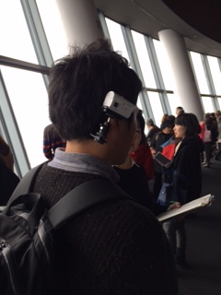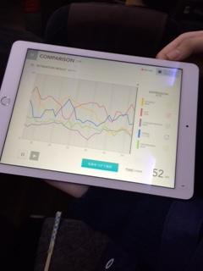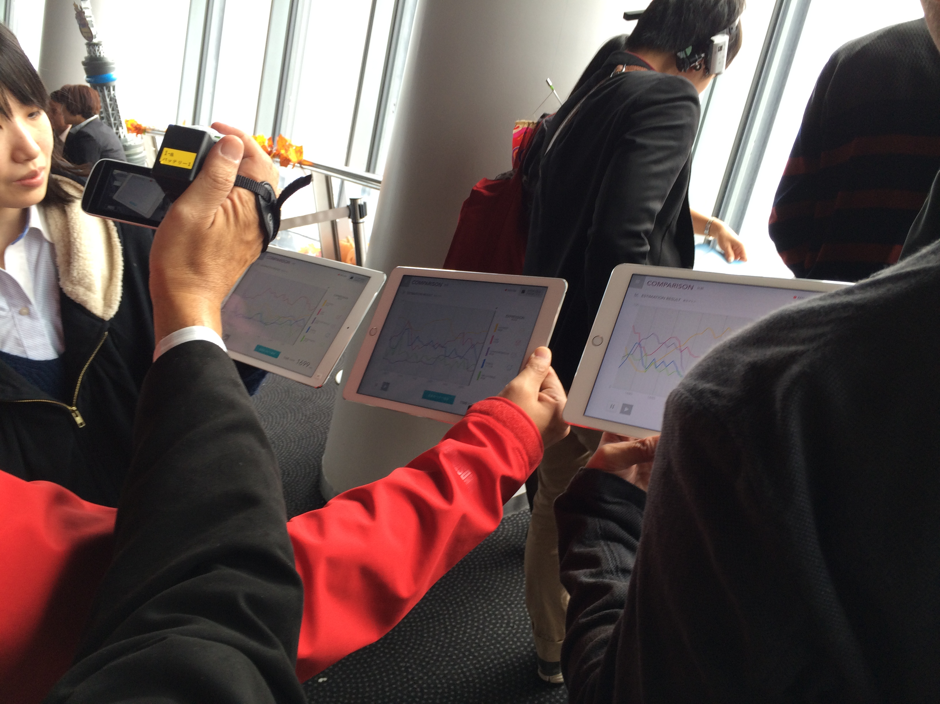

Once again, with respect to the data on location, the data on moving, the data of tourists attributes and the data on the reaction to the attractions, they can be obtained in real time. If researchers collect vast amounts of data and analyze the meaning, the science of evaluation of tourist attractions would be developed as the figure eight. Then, we might be able to find something like tourism-related-culture gene corresponding to meme named by Clinton Richard Dawkins. At that time, Human Logistics science would be converging on brain science.
Thank you for giving me this chance.

